To Whom it may Concern

29 November 2018

Dear Sirs

Re: Fishers Farm Park Ltd

We act as Insurance Brokers to the above company and confirm that the following insurance
covers are in force:-

Employers Liability Insurance

Insurer: Catlin Insurance Company (UK) Ltd
Policy: Combined Sport & Leisure Insurance
Policy No: 1843928/0
Period: 16th November 2018 to 15th November 2019
Limit of Liability: £10,000,000 any one event

Public/Products Liability Insurance

Insurer: Catlin Insurance Company (UK) Ltd
Policy: Combined Sport & Leisure Insurance
Policy No: 1843928/0
Period: 16th November 2018 to 15th November 2019
Limit of Liability: £5,000,000 any one event and in respect of Products Liability
in any one period of insurance.

Excess Public/Products Liability Insurance

Insurer: Catlin Insurance Company (UK) Ltd

Policy: Excess of Loss Public & Products Liability Insurance

Policy No: X17-0082-XSOL

Period: 16th November 2018 to 15th November 2019

Limit of Liability: £5,000,000 in excess of £5,000,000 000 any one event and in respect
of Products Liability in any one period of insurance

Total Public/Products Limit of Liability £10,000,000

This document is furnished to you as a matter of information only and does not make the person or organisation to whom it has been issued an additional assured, nor does it modify in any manner the contract of insurance between the Policyholder and Insurer.

Should the above mentioned policies be changed or cancelled during the above Period of Insurance, no obligation to inform the holder of this document is accepted by ourselves.

Yours Sincerely

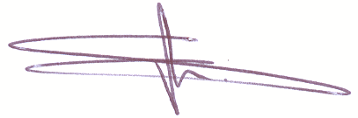

Steve Taylor
Associate Director
Direct Dial: 0116 – 204 3415
Email: staylor@marshcompany.co.uk

